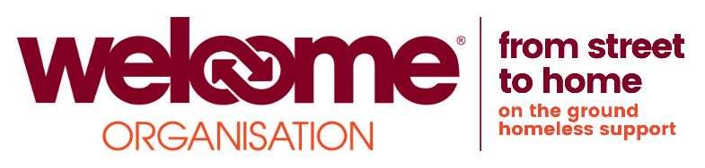

**Bank Staff - Outreach, Drop-In, Annsgate, Catherine House**

**Closing date:**

**Rate of pay:** £12.46 -£12.88 per Hour

We are looking for individuals who are committed, enthusiastic and self-motivated to join our energetic team. You will have experience of working with marginalised people with a range of support needs and risks.

We are looking for individuals who are committed, enthusiastic and self-motivated to join our energetic team. You will have experience of working with marginalised people with a range of support needs and risks, be able to positively engage with homeless people and have a strong understanding of homelessness issues. You must be able to work to the Welcome’s ethos of acceptance and delivering services unconditionally. In return, we will provide the opportunity to develop your skills, professional supervision and support, and the opportunity to be part of a team where your views count and you can make a lasting difference to the lives of homeless people

**Assertive Outreach Worker**

You will have a basic understanding of Homelessness, be empathetic, self-motivated and compassionate.

You must have a full driving licence for 2yrs.

You must be able to work to the Welcome’s ethos of acceptance and delivering services unconditionally.

In return we will support you and provide you with the opportunity to develop your skills and knowledge. You will be a valuable member of our team and make a difference to so many lives

**F/T Catherine House Support Worker**

This is an exciting opportunity to break the cycle of homelessness which some females experience. Support Workers will support the service manager and coordinator to ensure the provision of high standards within Catherine House our new innovative 10-unit therapeutic housing scheme for women.

The women staying at the scheme will have a variety of complex and multiple needs resulting in significant histories of trauma, repetitive periods of homelessness and will have struggled to engage with other support services. Catherine House aims to help women out of homelessness using a therapeutic support model, designed to enable women to gain the skills and confidence needed to take the next steps to living independently.

**Annsgate Emergency Accommodation**

We are looking for people who are committed, enthusiastic and self-motivated to join our team. You will have experience of working with marginalised people with a range of support needs and risks, be able to positively engage with homeless people and have a strong understanding of homelessness issues. You must be able to work to the Welcome’s ethos of acceptance and delivering services unconditionally.

In return, we will provide the opportunity to develop your skills, professional supervision and support, and the opportunity to be part of a team where your views count and you can make a lasting difference to the lives of homeless people.

**Drop In Support Worker**

We are looking for individuals who are committed, enthusiastic and self-motivated to join our energetic team. You will have experience of working with marginalised people with a range of support needs and risks, be able to positively engage with homeless people and have a strong understanding of homelessness issues. You must be able to work to the Welcome’s ethos of acceptance and delivering services unconditionally.  
In return, we will provide the opportunity to develop your skills, professional supervision and support, and the opportunity to be part of a team where your views count and you can make a lasting difference to the lives of homeless people.